**INSTALLATION OF PYTHON 3.9.8**

|  |  |
| --- | --- |
| **Date** | 16.11.22 |
| **Team ID** | PNT2022TMID45918 |
| **Project Name** | IOT BASED SMART CROP PROTECTION SYSTEM OF AGRICULTURE |

Step 1: Type python in google and click on the first link

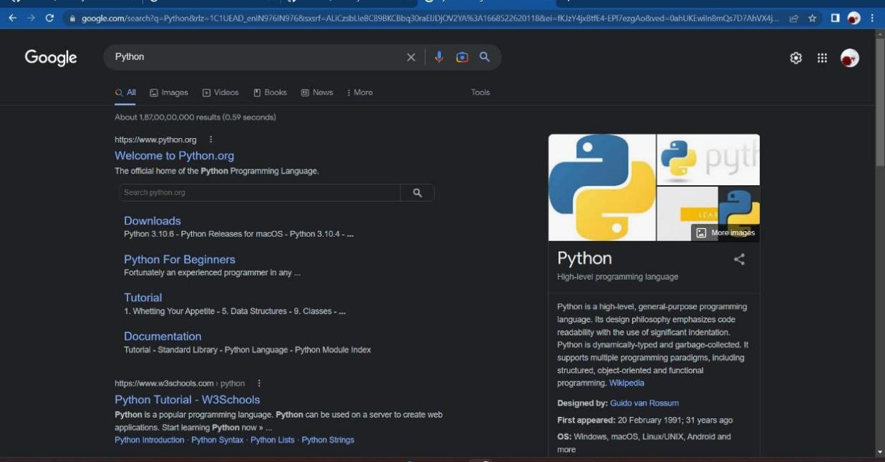

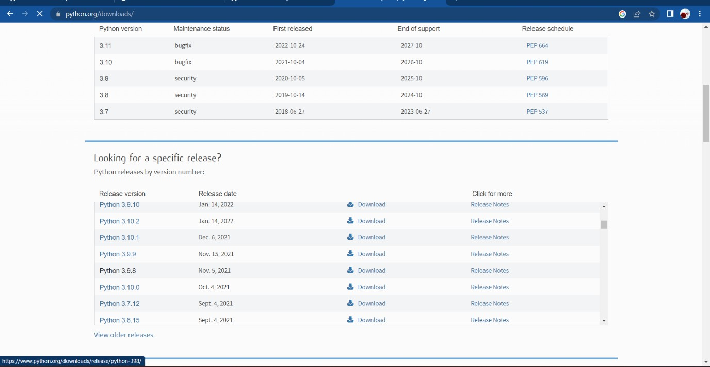

Step 3: Scroll down to reach Files and click on “Window installer (64 bit)

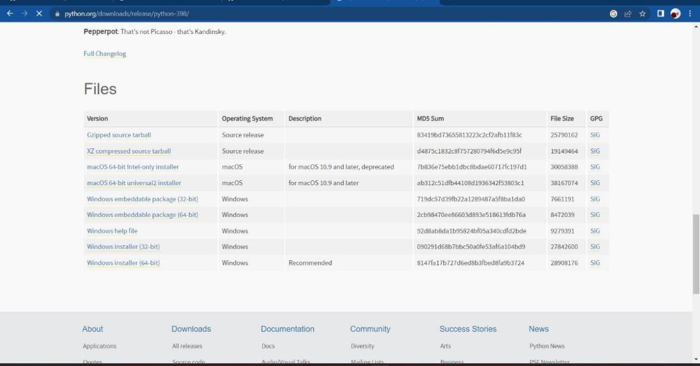

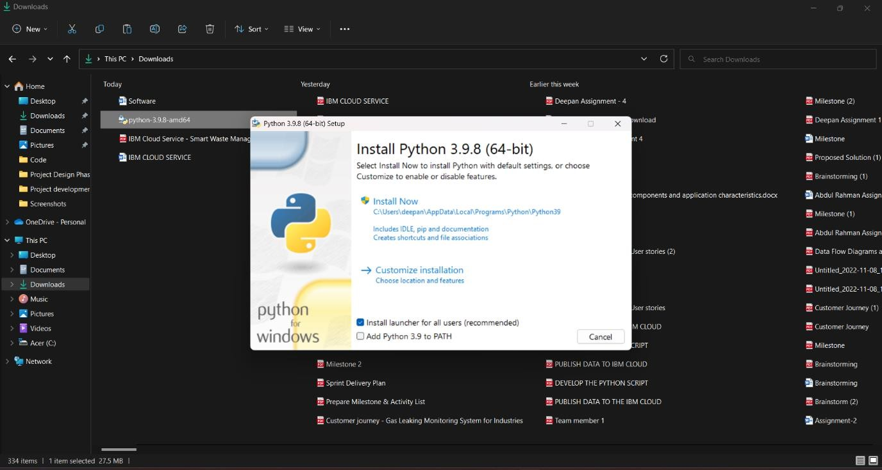

Step 5: Installation on progress

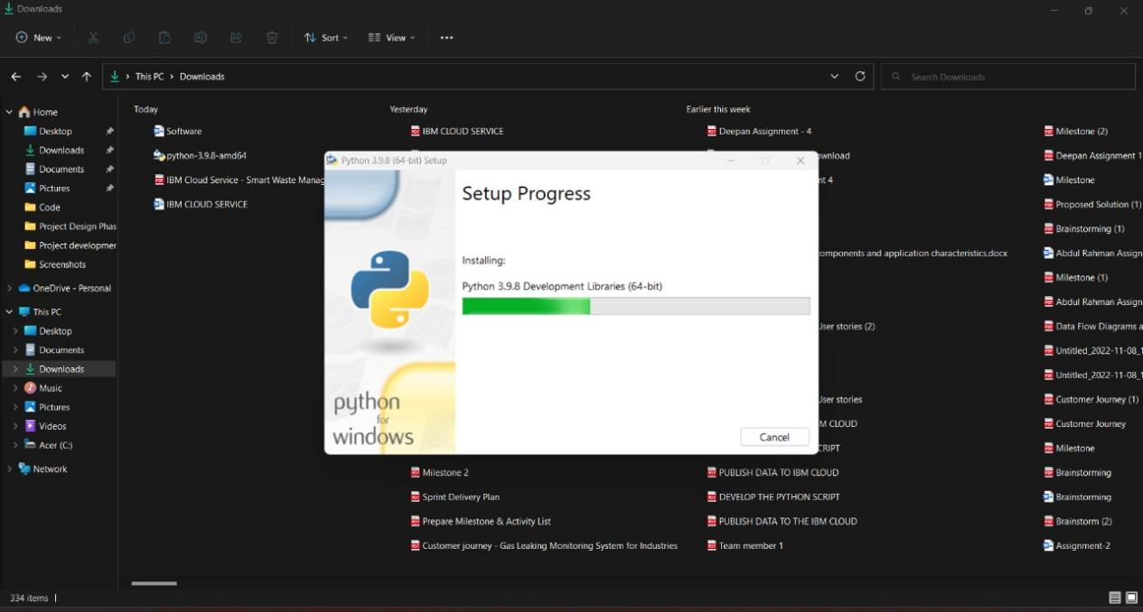

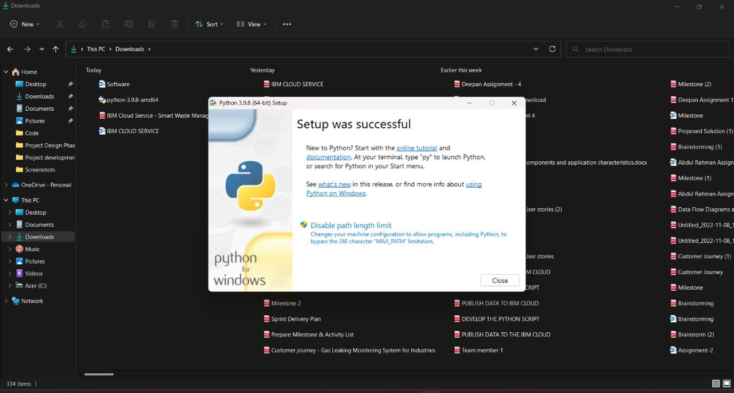

Step 7: Search IDLE

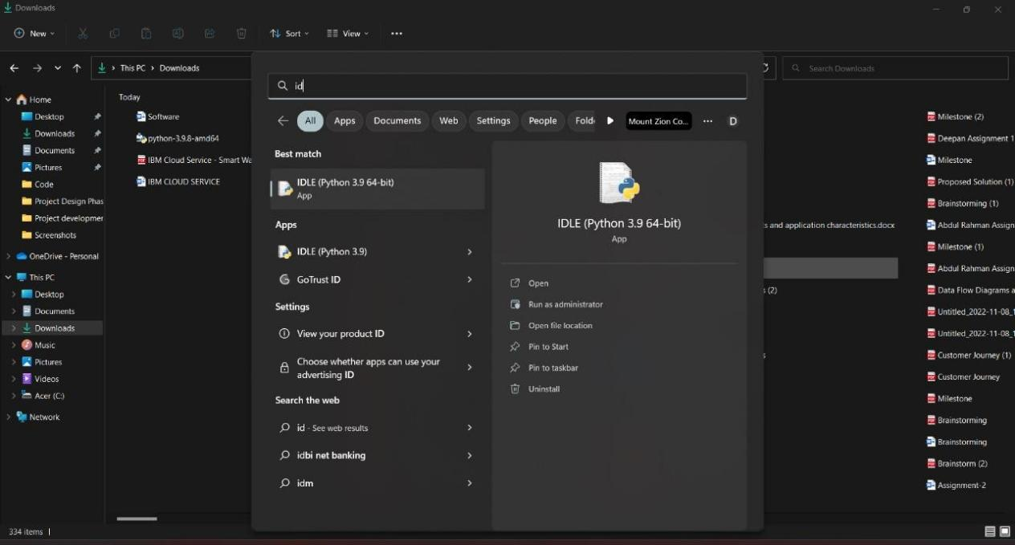

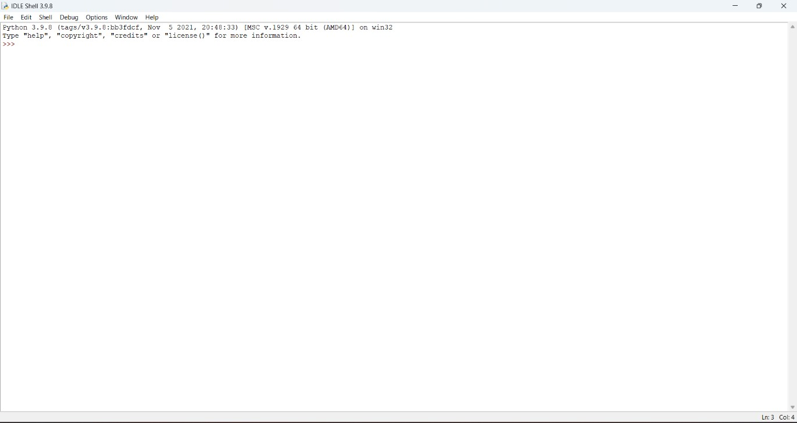

Step 9: Go to file and click on New File

